**A Project Report**

**On**

**Online book shopping/rent system**

**Submitted By**

**Patel Sanketkumar Mukeshkumar (206230316018)**

**Joshi Shubh (206230316068)**

**Raval Sahilkumar Bharatbhai (206230316091)**

**Khokhar Mohammed Hamza (206230316071)**

**In Partial Fulfillment of requirement of degree**

**Of**

**DIPLOMA ENGINEERING**

**In**

**Information Technology Engineering**



**Government Polytechnic, Gandhinagar**

**Gujarat Technological University- Ahmedabad.**

**December – 2022**

**CERTIFICATE**



**Government Polytechnic, Gandhinagar**

Information Technology

2022-2023

This is to certify that the project work embodied in this report entitled “**Online book shopping/rent system**” was carried out by **Patel Sanketkumar Mukeshkumar (206230316018) at Government Polytechnic, Gandhinagar** for partial fulfillment of Diploma degree to be awarded by Gujarat Technological University (GTU). This project work has been carried out under my supervision and is to the satisfaction of department.

Place: GP, Gandhinagar

Date:

**Internal Guide** **Head** **of** **the** **Department** Mr. Eshan Panchal Ms.Hiral.R .Patel

**CERTIFICATE**



**Government Polytechnic, Gandhinagar**

Information Technology

2022-2023

This is to certify that the project work embodied in this report entitled “**Online book shopping/rent system**” was carried out by **Joshi Shubh (206230316068) at Government Polytechnic, Gandhinagar** for partial fulfillment of Diploma degree to be awarded by Gujarat Technological University (GTU). This project work has been carried out under my supervision and is to the satisfaction of department.

Place: GP, Gandhinagar

Date:

**Internal Guide** **Head** **of** **the** **Department** Eshan Panchal Ms.Hiral.R .Patel

**CERTIFICATE**



**Government Polytechnic, Gandhinagar**

Information Technology

2022-2023

This is to certify that the project work embodied in this report entitled “**Online book shopping/rent system**” was carried out by **Raval Sahilkumar Bharatbhai (206230316091) at Government Polytechnic, Gandhinagar** for partial fulfillment of Diploma degree to be awarded by Gujarat Technological University (GTU). This project work has been carried out under my supervision and is to the satisfaction of department.

Place: GP, Gandhinagar

Date:

**Internal Guide** **Head** **of** **the** **Department** Eshan Panchal Ms.Hiral.R .Patel

**CERTIFICATE**



**Government Polytechnic, Gandhinagar**

Information Technology

2022-2023

This is to certify that the project work embodied in this report entitled “**Online book shopping/rent system**” was carried out by **Khokhar Mohammed Hamza (206230316071) at Government Polytechnic, Gandhinagar** for partial fulfillment of Diploma degree to be awarded by Gujarat Technological University (GTU). This project work has been carried out under my supervision and is to the satisfaction of department.

Place: GP, Gandhinagar

Date:

**Internal Guide** **Head** **of** **the** **Department** Eshan Panchal Ms.Hiral.R .Patel

**Abstract**

Online book Shopping/Rent System is a form of electronic shopping store where the buyer is directly online to the seller’s computer usually via the internet. There is no intermediary service. The sale and purchase transaction is completed electronically and interactively in real- time

It is useful in the way that it makes an easier way to buy and sell book online. This application is an interactive e-commerce solution providing users with an opportunity to buy and rent a book

In this website we have basically 2 modules. The first module includes the customer module and second module includes admin module. The user has to register for any enquiry related to product. The registered customer can view details of product and he/she can buy or sell the product of his/her need. He/she has to pay and will get home delivery. The admin module contains the access of admin page on the website. The admin can change everything in the website. He has the ability to add, delete, and update any information regarding the products.

1. **Introduction**
   1. **Project Introduction**

* The e-commerce sector is seen the exponential growth thus a new option will easily part of this regatta of commercial website. The e-commerce website will feature the online book shopping/rent facility of various fashion products under a single web space. The proposed web application will allow business personnel to make their total business using it and increase their reach ability thousands of times more than today they have, over the internet. It will allow multiple shopping vendors to sale their products online. The product management in the system will be done in the form of categories. The safety of information is the main requirement of the system and will be handling according to that. To formulate this project first task is to do is cost estimation. For probabilistic assessment of the project cost estimation is required. Cost estimation covers the accurate; estimations of cost and effort required for the project.
  1. **Purpose**
* The objective of the project is to make an application in android platform to purchase items in an existing shop. In order to build such an application complete web support need to be provided. A complete and efficient web application which can provide the online book shopping experience is the basic objective of the project. The web application can be implemented in the form of an android application with web view
  1. **Scope**
* This system can be implemented to any shop in the locality or to multinational branded shops having retail outlet chains. The system recommends a facility to accept the orders 24*7 and a home delivery system which can make customers happy.
* If shops are providing an online portal where their customers can enjoy easy shopping from anywhere, the shops won’t be losing any more customers to the trending online shops such as flipcart or e-bay. Since the application is available in the Smartphone it is easily accessible and always available

1. **System Requirement Analysis**

System analysis is the process of gathering and interpreting facts, diagnosing problems and using the information to recommend improvements on the system. System analysis is a problem solving activity that requires intensive communication between the system users and system developers.

System analysis or study is an important phase of any system development process. The system is viewed as a whole, the inputs are identified and the system is subjected to close study to identify the problem areas. The solutions are given as a proposal. The proposal is reviewed on user request and suitable changes are made. This loop ends as soon as the user is satisfied with the proposal.

* 1. **Current System Study**

The current system for shopping is to visit the shop manually and from the available product choose the item customer want and buying the item by payment of the price of the item.

* 1. **Weakness of Current System**
* It is less user-friendly.
* User must go to shop and select products.
* It is difficult to identify the required product.
* Description of the product limited.
* It is a time consuming process
* Not in reach of distant users.
  1. **Project Identification / Definition**

As online book shopping became a trend nowadays the regular shops are losing their customers to online. Customers have effortless shopping experience and saving time through shopping online. For competing with those online brands , If shops are providing an online portal where their customers can shop through internet and get the book at their doors it will increase the number of customers.

* 1. **Feasibility study**

Feasibility study of the system is a very important stage during system design. The main aim of the feasibility study is to determine whether developing the project is financially and technically feasible. The feasibility study involves analysis of the problem and collection of data which would be input to the system, the processing required to be carried out on these data, the output data required to be produced by the system, as well as study of various constraints on the behavior of the system.

Mainly following aspects are taken into this stage:-

1. Technical Feasibility

2. Economical Feasibility

3. Operational Feasibility

* **Technical Feasibility:-**

It means management is able to afford computers having minimum configuration as per specified so that it can use the system. The system would be technically feasible as all the technical requirements are very minimal including only the basic hardware and software. The application is made in PHP so there is no problem at company in using this system. The system is completely technically feasible.

* **Economical Feasibility:-**

The system would be economically feasible, as it does not require any extra hardware or special software to implement it. We are using the software which is having free licensing so in coding we don’t require any special software. The project is based on internet so the company which is going to use this application does not require any extra software and hardware.

* **Operational Feasibility:-**

The System would be operationally feasible within the Organization, as it will make the entire process more easy than before and also very fast rather than time consuming. The system was developed only after making the feasibility study and thus making it assured that the project is feasible in all the aspects so that the developed system could be implemented successfully.

* 1. **Development model used**

Waterfall project management entails mapping out a project into distinct, sequential phases, with each new phase beginning only when the prior phase has been completed. The waterfall system is the most traditional method for managing a project, with team members working in a linear fashion towards a set end goal. Each participant has a clearly defined role and none of the phases or goals is expected to change.

Waterfall project management works best for projects with long, detailed plans that require one phase to be done before another can start. These projects require a single timeline and changes are often discouraged and costly. This is in contrast to agile project management, which involves shorter project cycles, constant testing and adaptation, and simultaneous overlapping work by multiple teams or contributors.



* 1. **Requirement validation**
* Requirements validation is concerned with showing that the requirements actually define the system, which the customer wants. It has much in common with analysis as it is concerned with finding problems with the requirements. Requirements validation is important because errors in a requirements document can lead to extensive rework costs when they are subsequently discovered during development or after the system is in service. The cost of making a system change resulting from a requirements problem is much greater than repairing design or coding errors.
* Requirement Validation examines the specification to ensure that all system requirements have been stated unambiguously; that errors have been detected and corrected. Primary requirements validation mechanism is Formal Technical Review.
  1. **Tools and technology**

The various system tools that have been used in developing both the front end and the back end of the project are being discussed in this Topic.

* **FRONT END:**

HTML, CSS, JAVA SCRIPT are utilized to implement the frontend.

* **HTML**

The hypertext markup language (HTML) is a simple markup language. Used to create a hypertext documents that are portable from one platform to another HTML documents are SGML (Standard generalized markup language) documents with generic semantics that are appropriate for representing information from a wide range of applications.

WHY TO USE HTML?

Website is a collection of pages, publications, and documents that reside on web server. While these pages publications and a document as a formatted in a single format, you should use HTML for home page and all primary pages in the site. This will enable the millions of web users can easily access and to take advantage of your website.

HTML is considered first for formatting any new material you plan to publish on the web. HTML documents are platform independent, meaning that they don’t confirm to any standard. If they are created properly you can move home page to any server platform or you can access them with any complaint www browser.

* **CSS**

What is CSS?

* CSS stands for Cascading Style Sheets
* CSS describes how HTML elements are to be displayed on screen, paper, or in other media
* CSS saves a lot of work. It can control the layout of multiple web pages all at once
* External style sheets are stored in CSS files
* **JavaScript**

JS is a dynamic computer programming language. It is most commonly used as part of web browsers, whose implementations allow client-side scripts to interact with the user, control the browser, communicate asynchronously, and alter the document content that is displayed.

Java Script is used to create popup windows displaying different alerts in the system like “User registered successfully” ”Product added to cart” etc.

* **Bootstrap**

Bootstrap is a free and open-source collection of tools for creating websites and web applications. It is the most popular HTML, CSS, and JavaScript framework for developing responsive, mobile-first web sites. It solves many problems which we had once, one of which is the cross browser compatibility issue. Nowadays, the websites are perfect for all the browsers (IE, Firefox and Chrome) and for all sizes of screens (Desktop, Tablets, and Phones). All thanks to Bootstrap developers -Mark Otto and Jacob Thornton of Twitter, though it was later declared to be an open-source project.

Why Bootstrap?

• Faster and Easier Web-Development.

• It creates Platform-independent web-pages.

• It creates Responsive Web-pages.

• It’s designed to be responsive to mobile devices too.

Websites which were built with a lot of CSS and JavaScript can now be built with a few lines of code using Bootstrap. Bootstrap comprises of mainly three components:

• CSS

• Fonts

• JavaScript

* **BACKEND:**

The back end is implemented using PHP and MYSQL which is used to design the databases.

* **PHP**

PHP is a server side scripting language. That is used to develop Static websites or Dynamic websites or Web applications. PHP stands for Hypertext Pre-processor, that earlier stood for Personal Home Pages.

**WHY USE PHP?**

You have obviously head of a number of programming languages out there; you may be wondering why we would want to use PHP as our poison for the web programming. Below are some of the compelling reasons.

* PHP is open source and free.
* Short learning curve compared to other languages such as JSP, ASP etc.
* Large community document
* Most web hosting servers support PHP by default unlike other languages such as ASP that need IIS. This makes PHP a cost effective choice.
* PHP is regular updated to keep abreast with the latest technology trends
* Other benefit that you get with PHP is that it’s a server side scripting language; this means you only need to install it on the server and client computers requesting for resources from the server do not need to have PHP installed; only a web browser would be enough.
* PHP has in built support for working hand in hand with MYSQL; this doesn’t mean you can’t use PHP with other database management systems.
* **MYSQL**

MYSQL is the world's second most widely used open-source relational database management system (RDBMS). The SQL phrase stands for Structured Query Language.

MYSQL is a fast, easy-to-use RDBMS being used for many small and big businesses. MYSQL is developed, marketed and supported by MYSQL AB, which is a Swedish company. MYSQL is becoming so popular because of many good reasons −

* MYSQL is released under an open-source license. So you have nothing to pay to use it.
* MYSQL is a very powerful program in its own right. It handles a large subset of the functionality of the most expensive and powerful database packages.
* MYSQL uses a standard form of the well-known SQL data language.
* MYSQL works on many operating systems and with many languages including PHP, C, C++, JAVA, etc.
* MYSQL works very quickly and works well even with large data sets.
* MYSQL is very friendly to PHP, the most appreciated language for web development.
* MYSQL supports large databases, up to 50 million rows or more in a table. The default file size limit for a table is 4GB, but you can increase this (if your operating system can handle it) to a theoretical limit of 8 million terabytes (TB).

MYSQL is customizable. The open-source GPL license allows programmers to modify the MYSQL software to fit their own specific environments.

* 1. **System Architecture**

System design is the process of defining the components, modules, interfaces, and data for a system to satisfy specified requirements. System development is the process of creating or altering systems, along with the processes, practices, models, and methodologies used to develop them.

System Design includes diagrams for the software development that helps excessively to develop proper planned software.

* 1. **Data flow Diagram**
* A Data Flow Diagram (DFD) is a graphical representation of the movement of data. A DFD includes main four components listed below:
* Processes.
* External Entities.
* Data Stores.
* Data Flows.
* Data Flow Diagram shows the processes of software, in flow of data, out flow of data from the Data store.

**Context Level DFD**

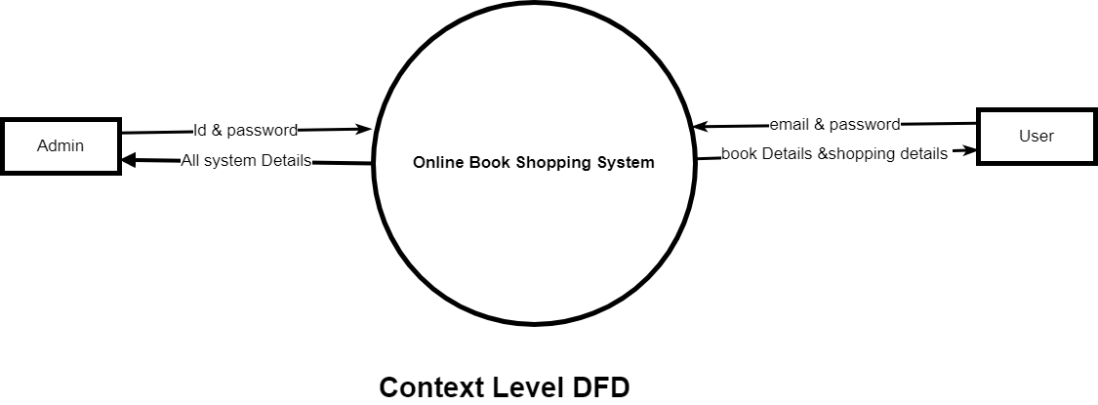

**First Level DFD**

* **Admin**

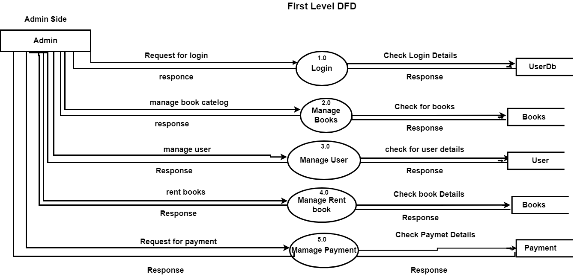

* **User**

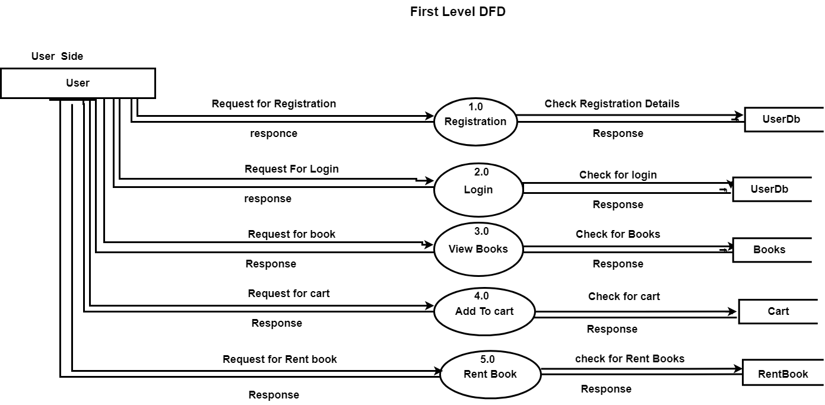

**System Flow Diagram**

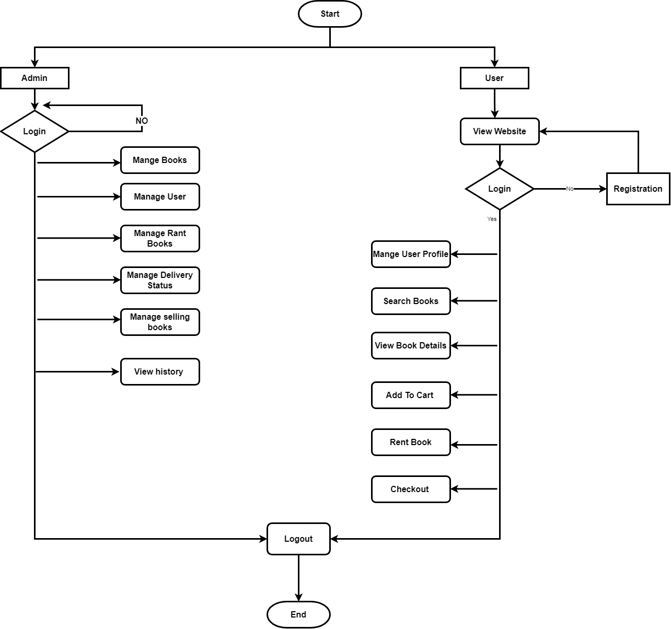

1. **System Design**

System design is the process of defining the components, modules, interfaces, and data for a system to satisfy specified requirements. System development is the process of creating or altering systems, along with the processes, practices, models, and methodologies used to develop them.

System Design includes diagrams for the software development that helps

excessively to develop a proper planned software.

* 1. **E-R Diagram**

About Entity Relationship Diagram:

* An entity relationship diagram (ERD) shows the relationships of entity sets stored in a database. An entity set is a collection of similar type of entities. These entities can have attributes that describe its properties.
* By defining the entities, their attributes, and showing the relationships between them, an ER diagram illustrates the logical structure of databases.
* ER model allows you to draw Database Design. It is an easy-to-use graphical tool for huge data. It is widely used in Database Design.

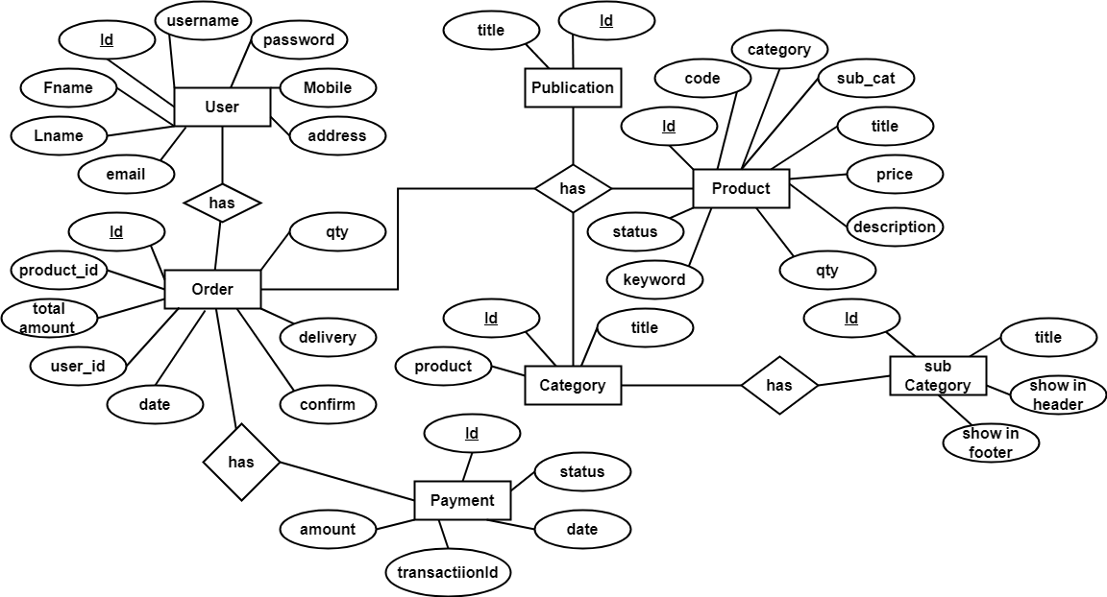

* 1. **Database Design**

Database design is the organization of data according to a database model. The designer determines what data must be stored and how the data elements interrelate.

The design process consists of the following steps:

* Determine the purpose of your database.
* Find and organize the information required.
* Divide the information into tables.
* Turn information items into columns.
* Specify primary keys.
* Set up the table relationships.
* Refine your design.
* Apply the normalization rules.
* **Data Dictionary**
* A Data Dictionary is a collection of names, definitions, and attributes about data elements that are being used or captured in a database.
* Data dictionaries are used to provide detailed information about the contents of a dataset or database, such as the names of measured variables, their data types or formats, and text descriptions.
* Data Dictionary is mostly helpful for DBA.

1. **Admin**

|  |  |  |
| --- | --- | --- |
| **Column Name** | **DataType** | **Constraint** |
| adminId | int | primary key |
| admin_name | varchar |  |
| username | varchar | not null |
| password | varchar |  |
| com_logo | varchar |  |
| com_email | varchar |  |
| com_phone | varchar |  |
| admin_role | bit |  |

1. **Publisher**

|  |  |  |
| --- | --- | --- |
| **Column Name** | **DataType** | **Constraint** |
| id | int | primary key |
| name | varchar |  |
| cat | int |  |

1. **Category**

|  |  |  |
| --- | --- | --- |
| **Column Name** | **DataType** | **Constraint** |
| id | int | primary key |
| name | varchar |  |
| product | int |  |

1. **Order_products**

|  |  |  |
| --- | --- | --- |
| **Column Name** | **DataType** | **Constraint** |
| id | int | primary key |
| product_id | int | foreign key |
| product_qty | int |  |
| total_amount | int |  |
| orderdate | varchar |  |
| pay_req_id | varchar |  |
| confirm | bit |  |
| delivery | bit |  |

1. **Payment**

|  |  |  |
| --- | --- | --- |
| **Column Name** | **DataType** | **Constraint** |
| id | int | primary key |
| item_number | int |  |
| txn_id | int |  |
| payment_gross | float |  |
| currency_code | varchar |  |
| payment_status | varchar |  |

1. **Products**

|  |  |  |
| --- | --- | --- |
| **Column Name** | **DataType** | **Constraint** |
| id | int | primary key |
| product_code | varchar |  |
| product_cat | int |  |
| product_sub_cat | int | foreign key |
| product_publisher | int | foreign key |
| product_title | varchar |  |
| product_price | varchar |  |
| product_desc | text |  |
| featured_image | text |  |
| qty | int |  |
| product_keywords | text |  |
| product_views | int |  |
| product_statust | int |  |

1. **Sub_category**

|  |  |  |
| --- | --- | --- |
| **Column Name** | **DataType** | **Constraint** |
| id | int | primary key |
| Title | varchar |  |
| cat_parent | int |  |
| cat_product | int |  |
| show_in_header | bit |  |
| show_in_footer | bit |  |

1. **User**

|  |  |  |
| --- | --- | --- |
| **Column Name** | **DataType** | **Constraint** |
| id | int | primary key |
| fname | varchar |  |
| lname | varchar |  |
| username | varchar |  |
| email | varchar |  |
| password | varchar |  |
| mobile | varchar |  |
| address | varchar |  |
| city | varchar |  |
| user_role | int |  |

1. **Options**

|  |  |  |
| --- | --- | --- |
| **Column Name** | **DataType** | **Constraint** |
| id | int | primary key |
| site_name | varchar |  |
| site_title | varchar |  |
| site_logo | varchar |  |
| footer_text | varchar |  |
| currency_format | varchar |  |
| contact_phone | varchar |  |

* 1. **User GUI**
* **Login page**

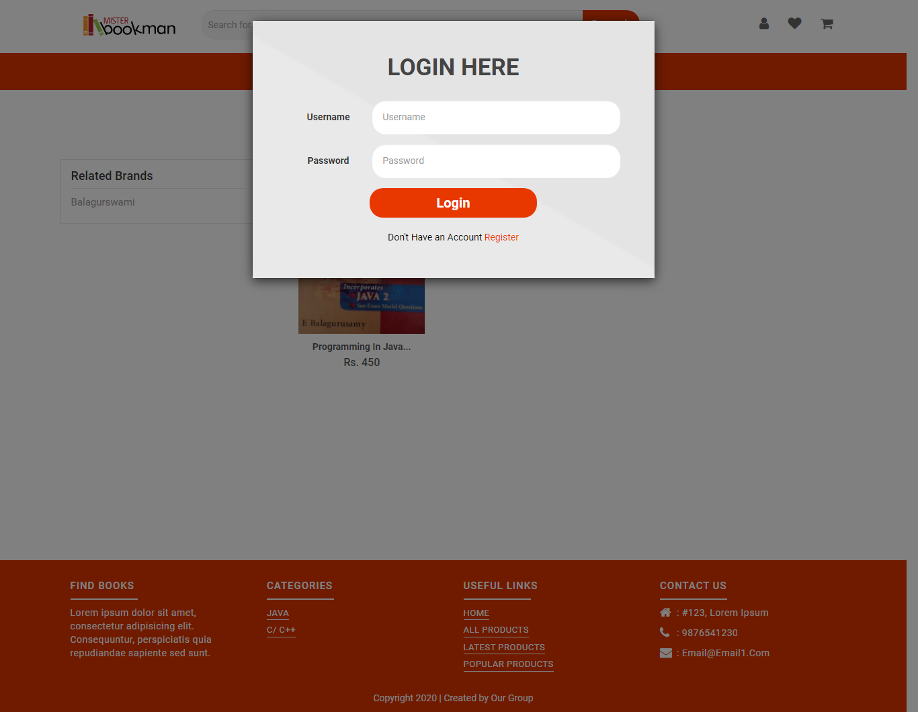

* **Registration Page**

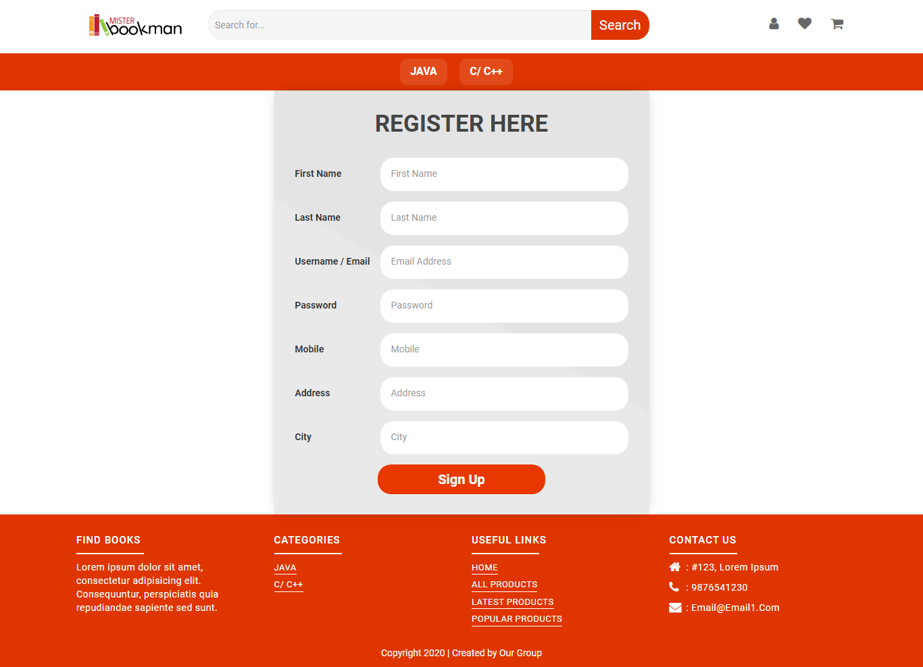

1. **System Development**

It is a pattern or a format in which the developers make their Project in the same, it includes some modules like Coding Standards, Tools Explanation, System Flow.

* **Coding Standard**
* Naming and Coding convention are the basic names that are most commonly used in a pattern/manner given to the variables in programs, tables in databases, columns
* in tables of databases. For example: LoginButton (which described that the function on the Button control is to run some Login code).
* Coding Convention in a Program: Firstly, the Control’s Function and secondly the Control’s name. We will use Camel Case Notation for this Coding Convention. For example: TextboxUsername.
* Column names in tables of database: Firstly, a short Abbreviation of the table name and secondly the Column’s short description. We will use Camel Case Notation for this Coding Convention. For example: StfID.

1. **Testing**

Testing is the process of evaluating a system or its component(s) with the intent to find whether it satisfies the specified requirements or not.

Testing is executing a system in order to identify any gaps, errors, or missing requirements in contrary to the actual requirements.

* **Testing Plan**
* Test planning, the most important activity to ensure that there is initially a list of tasks and milestones in a baseline plan to track the progress of the project. It also defines the size of the test effort.
* It is the main document often called as master test plan or a project test plan and usually developed during the early phase of the project.
* **Testing Strategy**
* Test Strategy is also known as test approach defines how testing would be carried out. Test approach has two techniques:
  + Proactive - An approach in which the test design process is initiated as early as possible in order to find and fix the defects before the build is created.
  + Reactive - An approach in which the testing is not started until after design and coding are completed.
* **Testing Methods**
* There are different methods that can be used for software testing.

1. **Black-Box Testing:** The technique of testing without having any knowledge of the interior workings of the application is called black-box testing.
2. **White-Box Testing:** White-box testing is the detailed investigation of internal logic and structure of the code. White-box testing is also called glass testing or open-box testing.
3. **Grey-Box Testing:** Grey-box testing is a technique to test the application with having a limited knowledge of the internal workings of an application.

* **Test Cases**
* A test case is a document, which has a set of test data, preconditions, expected results and post conditions, developed for a particular test scenario in order to verify compliance against a specific requirement.
* Test Case acts as the starting point for the test execution, and after applying a set of input values, the application has a definitive outcome and leaves the system at some end point or also known as execution post condition.

1. **Conclusion**

* The software is developed to fulfill client requirements with flexible & easy platform. So anyone can use the system easily & administrator can easily maintain system.
* After some modifications it can be used widely by any education correspondence providing institute around world.
* System provides more security, accuracy, efficiency and less costly. It meets all the requirements of client as expected.
* From this project I have learnt lots of things such as Gone through Complete Software Development Life Cycle, how the project is handled in real world, , able to make better documentation, got knowledge about latest technologies in php. It makes my thinking broader. Not only technical things but also non – technical things like how to behave with seniors, communication aspects, how to develop your personality, how to deal with problems occurred in your project.
  1. **Future work**
* The Website is not accessible to everyone. It can be deployed on a web server so that everybody who is connected to the Internet can use it.
* We implement Payment gateway for online payment
* Implement book review module

1. **Bibliography**

The following books were referred during the analysis and execution phase of the project

* **Books**
  + Ivan Bayross, Sharanam Shah :PHP 5.1 For Beginners,Sh off Publishers & Distributors(SPD)
  + Janet Valade : PHP5 & MYSQL Projects, Wiley Dreamtech

* **Website**
  1. <https://www.w3schools.com/php/default.asp>
  2. <https://www.w3schools.com/js/js_ajax_intro.asp>
  3. <https://getbootstrap.com/docs/4.5/getting-started/introduction/>
  4. <https://fontawesome.com/icons?d=gallery>